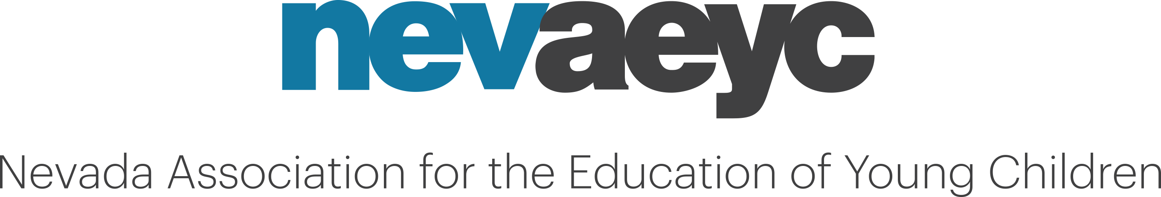

NevAEYC Board Meeting
Date: March 15, 2021
Location: Teleconference
https://global.gotomeeting.com/join/363687669
Or phone: +1 (312) 757-3121
Access Code: 363-687-669
Attendance:
Board Members-Elected | Board Members-Appointed | NevAEYC Employees
LeAn Shelton  President | Patrice Gardner  Board Development Chair | John Cregg  NevAEYC Exec. Director
Amanda Haboush-Deloye  Past-President | Carrie Paldi ABSENT  ECAC Liaison | Bryanna Timmsen  Administrative Assistant
Brandy Timmsen  Treasurer | Jencie Davies  T.E.A.C.H. Advisory Chair | Bridget Perez  T.E.A.C.H. Program Specialist
Brianna Cambra  Secretary | Emily Bailey  Northeastern Representative
Anna Villatoro  VP Communication & Technology | Maureen Price  Northwestern Representative
Danielle Holmes  VP Membership | Mirna Mejia  Conference Chair
Kathy Yoder-Bass  VP Educational Development | Chapter Representatives
Evelyn Knight  VP Public Policy | Marissa Meehan-Goff  Southern Nevada Chapter

- Call to Order – Meeting called to order at 6:02 p.m.
Roll Call: Taken Quorum Established: Yes

- Action Items
  - Secretary
    - Approval of minutes from January 30, 2021 –
Motion: Amanda Haboush-Deloye Second: Kathy Yoder-Bass
Vote: (Y): 13 (N):0 (A):0

  - Treasurer
    - Approval of January 2021 Financial Statement
Motion: Kathy Yoder-Bass Second: Jencie Davies
Vote: (Y):13 (N):0 (A):0

  - President
    - Recommendations for purchase approval of Laptop.
Vote: (Y):13 (N): 0 (A):0

  - Membership
    - Recommendations from committee that membership scholarships be used for early childhood graduates. Board encourages that graduates be selected from each region of the State if available.
Vote: (Y): 13 (N): 0 (A):0

- Unfinished Business

- New Business
  - Board Effectiveness Survey
    - Reviewed results and opened discussion.
  - Position Statement - Education Subcommittee
    - During subcommittee meeting on PreK Budget, discussion included shifting PreK funding from non-profit entities to only K-12 system because “this is not daycare, this is education”
    - John Cregg drafted letter and Board reviewed and offered suggested edits. John will make changes and send to Evelyn for review prior to distribution to committee members.
- Officer Reports
  - President - Received

  - Past President - Received

  - VP of Communication & Technology – Received

  - VP of Educational Development – Received
    - Kathy will send an invitation to committee for anyone interested.

  - VP of Membership – Received
    - Developed three new strategies to focus on including recognizing providers with a thank you basket, hosting a director chat, and spotlight a teach a week on social media.
    - Kathy has a contact for three parties trays from Capriottis and three boxes of Crumble cookies.

  - VP of Public Policy –
    - Many board members joined the Public Policy Forum for the first time.
    - AB122 – no updates regarding this bill.
    - Recommendation that the board should still communicate with representatives quarterly.

- Committee Reports

  - Board Development – Received
    - White fragility book study session 1 took place.
    - Patrice included supplemental resources to explore and will send an invitation for next meeting on 4/14/21 from 5:00-7:00p.m.

  - Early Childhood Advisory Committee – No Report

  - Northeastern Committee Representative – Received

    - Working on a survey of what benefits early learning professionals would be interested in.
    - Planning on a training day for the region

  - Northwestern Committee Representative –
    - 2 upcoming opportunities
      - Possibly Saturday April 17 or the 24th for “Loose Parts” Professional Development event. Potentially free registration and could open up to everyone.
      - Networking event possibly 5/8/21: Spring has sprung, self-guided walking tour. Have potential swag for this event. National Arbor day willing to

  - Conference – Received
    - 40 registered so far
    - Planning meeting tomorrow to review proposals
    - Expecting more registration via QRIS and as it gets closer to event.
    - Currently have 35 proposal and John could submit 1 more to make an even 36. Would revise Monday-Thursday, propose to offer 12:30-1:30.
      - AHD explained that sessions could repeat for M,T,W and we could overlap content.
      - JC is completing the schedule and will send to committee.

- T.E.A.C.H. Early Childhood® Nevada
  - Advisory Committee Chair – Received

  - Program Director – Received
    - Consistent at 148 scholarship recipients this year.
    - Call with DWSS to talk about potential scholarship funding opportunities.

- Chapter Reports
  - Southern Nevada Representative – Received
    - Winter mixer had two sessions – 7 attended morning, 13 people attended PM.
    - Week of young child carnival – 20 centers will have hands-on activities
      - Chapter will most likely have a table at event
    - Summer Mind in the Making mini conference

- Adjourn – Meeting was adjourned at 6:56p.m.

Reminder:
Next meeting – May 17, 2021
Board reports due – May 10, 2021
Agenda items for board meeting due – May 10, 2021
Location: Virtual

